**Monte Carlo model**

**1-Introduction…**

Since the beginning of electronic computing, people have been interested in carrying out random experiments on a computer. Such Monte Carlo techniques.

In this research I will talk about Monte Carlo model & its pros and cons.

I will also talk about:

• Who developed Monte Carlo model?

• When he made the model?

• Why this model was made?

• Why this model named as Monte Carlo model?

• Who can use this model?

**2-Explanation…**

Monte Carlo model is a mathematical technique depend on random variable generating. This model is used for modelling uncertain situation it’s used for simulating what is impossible to predict it’s result because of random variables. Monte Carlo model was developed by a mathematician **Stanislaw Ulam.** This model was introduced during **world war II** (1940s) during working on atomic bombs. Monte Carlo model was named for a city in **Monaco.** Monte Carlo model used in many different fields by many different actors. **Telecoms** use this model to increase the performance of network. **Insures** and **oil** well drillers also use them. Monte Carlo simulations has many applications outside of business and finance, such as in **meteorology**, **astronomy** and **particular physics**. Monte Carlo model is used also in **Engineering** and **artificial intelligence games.**

**−** **Uses of Monte-Carlo in fields:**

**• Monte Carlo model in engineering:**

1. In **wind energy** yield analysis, the predicted energy output of a wind farm during its lifetime.
2. In **Microelectronic engineering**, Monte Carlo methods are applied to analyze correlated and uncorrelated variations in **analog** and **digital integrated circuits.**

**• Monte Carlo model in finance:**

1. It can help investors taking a decision by estimating the effect of decision on the outcome.

• **Monte Carlo in artificial games:**

There is technique called Monte-Carlo tree search that is used for knowing the best move in games. Moves are organized in a search tree.

**Examples:**

1. **Battleship** game
2. **Havannah** game
3. **Bomb** game

**− Pros of Monte-Carlo model:**

1. **Monte-Carlo model** show the probability of each outcome for all results.
2. **Making Graphical Design** by knowing results from Monte Carlo model you can draw graph for the outcome which make it easily to everyone to understand the result.
3. **In Monte Carlo,** it’s easily to know which input has the biggest effect & this is known as **Sensitivity analysis.**
4. **In Monte-Carlo,** there is correlation between inputs so if any change occurred on the inputs, the final result will change.

− **Cons of Monte-Carlo model:**

1. **Monte-Carlo methods,** cannot give you accurate results because it depends on random variables.
2. **Monte-Carlo methods** based on excel can have serious operational errors and risks but it can be covered under some question

**4-Application:**

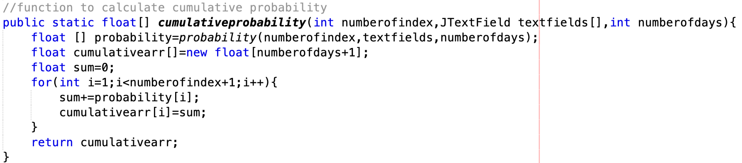

This function is used to get cumulative probability for the problem:

• The function has 3 parameters

1. **Number of indices:** to loop on it to get each probability and add it on the previous probability
2. **Array of text-field:** to send it as a parameter to function probability to take input probability from user
3. **Number of days:** to make array of number of days for calculating cumulative I know that cumulative must be with the same number of index but to show it on table must be with the biggest number

• There are 2 arrays

1. **Array of probability:** to get all probabilities from the returned function
2. **Cumulative array:** to add the sum of each cumulative probability array with [numberofdays+1] +1 because I loop from 1 to print in table from 1

• There is a variable called sum to assign the probability and the sum of previous probability on it and add the variable sum to the array **Cumulative array.**

**• The for loop** used to loop on all the **probability array** and **sum** each probability to the previous probabilities and add it to **cumulative array**

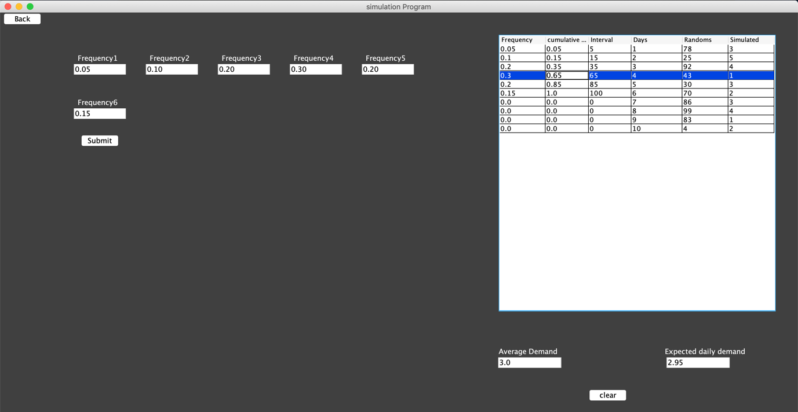



**•Front-end for cumulative probability**

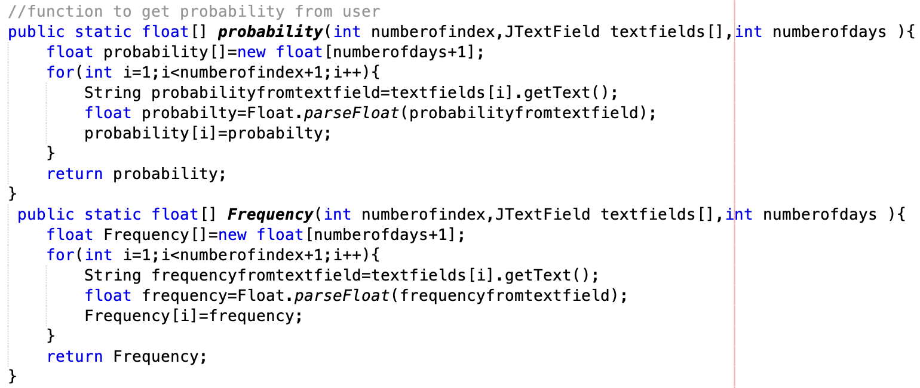

• **There is 2 functions probability & Frequency the both do almost the same function**

1. Both have the same parameters as I explained them before
2. The main function that the both do is to get the input from user from the text field

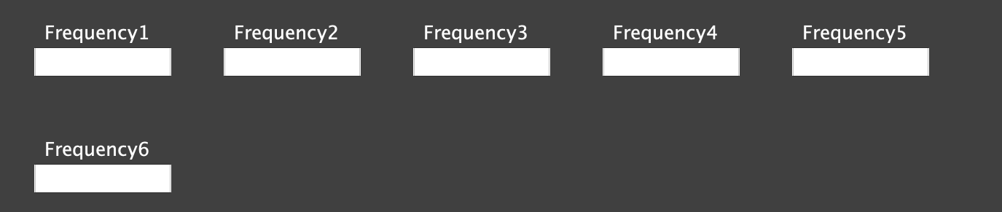

•**Front-end** of the both functions…

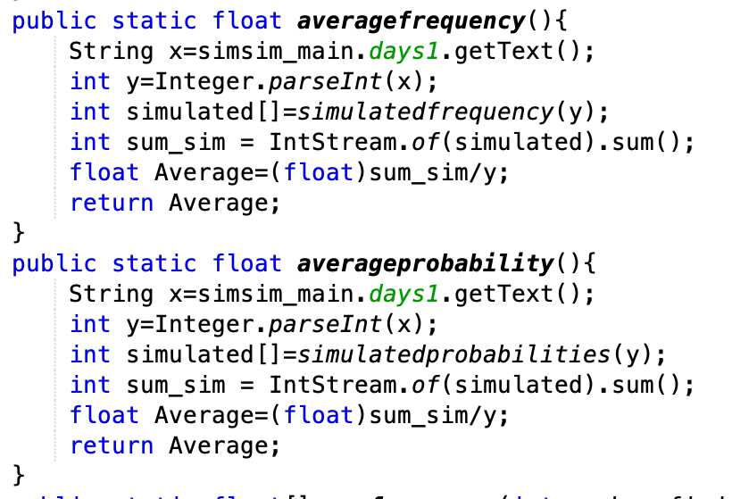

• This function used to return the average of probability and frequency

1. There is variable x (String) to get number of days from text-field
2. Variable y to cast string to int
3. Array of simulated to get the return from function simulated
4. Variable sum to sum the array (simulated)
5. Variable average (float) to divide the sum of the array by number of days

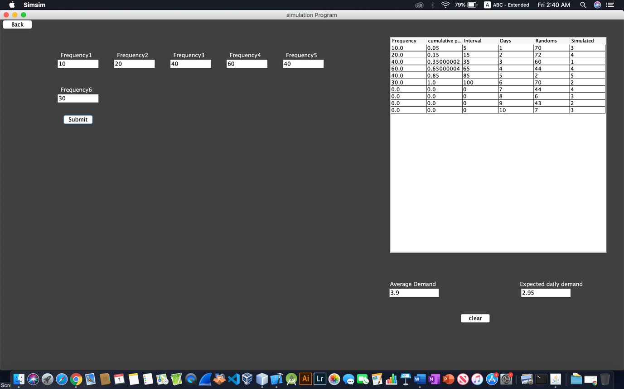



• The frond-end of the function average (Frequency-probability)

• References:

1. <https://www.solver.com/monte-carlo-simulation-overview>
2. <https://www.palisade.com/risk/monte_carlo_simulation.asp>
3. https://people.smp.uq.edu.au/DirkKroese/ps/whyMCM_fin.pdf